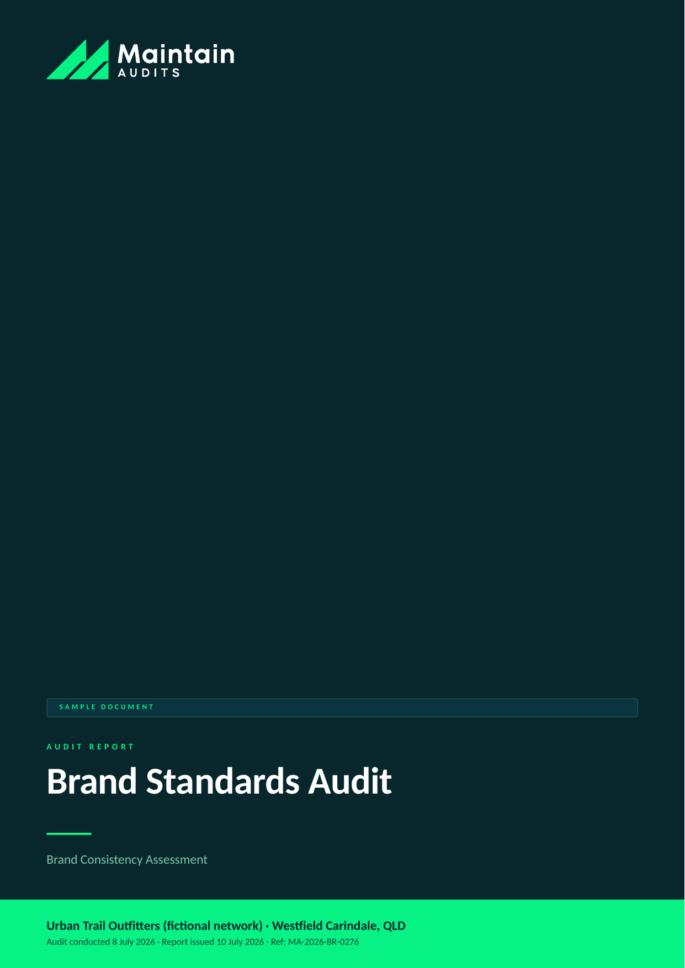

Client (fictional) | Urban Trail Outfitters (fictional network)
Location | Westfield Carindale, QLD
Audit type | Brand Standards Audit
Audit conducted | 8 July 2026
Report issued | 10 July 2026 (48-hour turnaround)
Lead auditor | S. Okafor, Brand Auditor — Maintain Audits
Report reference | MA-2026-BR-0276
Distribution | Franchisor head office; franchisee principal — Commercial in confidence

SAMPLE DOCUMENT — all client details and findings are fictional, prepared to demonstrate Maintain Audits' reporting format.

SECTION 1 │ EXECUTIVE SUMMARY

Urban Trail Carindale scored 79% against the network brand standard — a store with strong bones and a capable team, drifting from the brand book in ways that individually look small but collectively make the store feel like a discount outlet rather than the premium outdoor brand the network has invested in.
The most visible issues: handwritten sale signage throughout the front-of-store zone, a third-party product range (approximately 8% of displayed SKUs) never approved for range, and uniform compliance at roughly half the team. The campaign window was also mid-transition eleven days after the changeover deadline.
Every finding here is fixable within 30 days at minimal cost. The franchisee acknowledged most items on the day and had corrected two before we left the centre.

Overall Result
Measure | Result
Overall compliance score | 79% against network brand standard (target ≥ 90%)
Overall rating | Medium
Findings raised | 6
Most urgent action due | Remove unapproved product range (BR-02) — within 7 days

Findings by Risk Rating
Rating | Count
High | 2
Medium | 3
Low | 1

SECTION 2 │ SCOPE & METHODOLOGY

A full brand-consistency assessment against the Urban Trail Brand Book v6 and current campaign guide, covering everything a customer sees, hears, and takes home.

In Scope
- External presence — signage, façade, window displays, centre directory listing
- Visual merchandising — planogram compliance, campaign execution, ticketing and signage
- Product range integrity — approved range vs displayed SKUs
- Team presentation — uniform, grooming standard, name badges
- Customer-facing materials — bags, receipts, loyalty collateral, in-store audio
- Digital touchpoints — local social pages and Google Business Profile accuracy

How the Audit Was Conducted
- Unannounced half-day store audit using the 84-point brand checklist
- Photo documentation of all zones (188 photos on file)
- Displayed-SKU sample check against the approved range file (240 SKUs sampled)
- Local digital audit: Google Business Profile, Instagram, Facebook vs brand social guidelines
- Debrief with franchisee at close of audit

Risk Rating Scale
Rating | Meaning | Action required
Critical | Immediate threat to safety, legal compliance, or brand integrity. | Within 48 hours
High | Material non-compliance likely to cause customer, safety, or financial impact. | Within 7 days
Medium | Non-compliance with franchise standards; manageable if addressed promptly. | Within 30 days
Low | Minor deviation or housekeeping issue. | Within 90 days
Observation | Not a non-compliance; an improvement opportunity worth acting on. | At next review

SECTION 3 │ FINDINGS SUMMARY

ID | Area | Finding | Rating
BR-01 | Signage & ticketing | Handwritten sale signage across front-of-store | High
BR-02 | Range integrity | Unapproved third-party product range on display | High
BR-03 | Campaign execution | Winter campaign changeover incomplete 11 days after deadline | Medium
BR-04 | Team presentation | Uniform compliance at 3 of 6 team members | Medium
BR-05 | Digital presence | Google Business Profile hours wrong; unapproved local Instagram | Medium
BR-06 | Store environment | In-store audio playing commercial radio | Low

SECTION 4 │ DETAILED FINDINGS

HIGH | BR-01 — Handwritten sale signage across front-of-store

Rating | Area | Standard / reference | Remediate by
High | Signage & ticketing | Brand Book s.5.3 | Within 7 days

What we found: Fourteen handwritten fluoro sale cards were displayed in the entry and apparel zones. The brand ticketing suite (available in the portal print kit) was not in use anywhere in store. This is the single largest driver of the store's discount-outlet impression.
Evidence: Photos 004–019.
Recommended action: Remove all handwritten signage immediately and reprint from the portal ticket kit. Franchisee removed the entry-zone cards during the audit.
Responsible: Franchisee / store manager

HIGH | BR-02 — Unapproved third-party product range on display

Rating | Area | Standard / reference | Remediate by
High | Range integrity | Brand Book s.2.1; FA cl. 9.2 | Within 7 days

What we found: Nineteen of 240 sampled SKUs (7.9%) were from two suppliers not on the approved range file — including a budget hydration brand displayed alongside the network's exclusive-supply line, which breaches the network's supplier agreement terms as well as brand standards.
Evidence: SKU sample worksheet; photos 095–104; approved range file v2026.2.
Recommended action: Remove unapproved lines from display within 7 days. If the franchisee believes there is a genuine local range gap, the correct channel is a range submission to head office — we note the hydration category sell-through data may actually support one.
Responsible: Franchisee

MEDIUM | BR-03 — Winter campaign changeover incomplete 11 days after deadline

Rating | Area | Standard / reference | Remediate by
Medium | Campaign execution | Campaign guide W26; Brand Book s.6.2 | Within 7 days

What we found: The front window carries the current 'Alpine Ready' campaign, but the rear wall bay and fitting-room zone still display autumn campaign graphics and pricing, including two expired promotional prices still being honoured at the register.
Evidence: Photos 121–130; POS price check on two promoted lines.
Recommended action: Complete the changeover, remove expired promotional pricing, and adopt the campaign checklist sign-off (portal) with a photo submission to close each changeover.
Responsible: Store manager

MEDIUM | BR-04 — Uniform compliance at 3 of 6 team members

Rating | Area | Standard / reference | Remediate by
Medium | Team presentation | Brand Book s.7.1 | Within 30 days

What we found: Three team members observed in non-uniform outerwear (competitor-brand puffer jackets, in an outdoor retailer) and two without name badges. The store's uniform stock cupboard held ample supply in relevant sizes.
Evidence: Photos 141–144 (faces obscured); uniform stock check.
Recommended action: Reset the uniform standard at the next team meeting. Competitor-branded outerwear on the floor is a direct brand contradiction and should be treated as a hard rule.
Responsible: Store manager

MEDIUM | BR-05 — Google Business Profile hours wrong; unapproved local Instagram

Rating | Area | Standard / reference | Remediate by
Medium | Digital presence | Social & local digital guidelines s.3 | Within 30 days

What we found: The store's Google profile shows superseded trading hours (customers arriving to a closed store on Thursdays per two recent reviews) and an unofficial store-run Instagram account uses off-brand templates and has run two unapproved giveaway promotions.
Evidence: Screenshots on file; review extracts.
Recommended action: Correct trading hours immediately. Transition the local Instagram to the network's local-social template program, which permits store content within brand rails.
Responsible: Store manager / network marketing

LOW | BR-06 — In-store audio playing commercial radio

Rating | Area | Standard / reference | Remediate by
Low | Store environment | Brand Book s.8.4 | Within 90 days

What we found: Commercial FM radio (including competitor advertising) was playing in-store rather than the licensed brand playlist. The brand audio subscription is active and functional on the store account.
Evidence: Noted 10:20am–1:40pm; subscription status verified.
Recommended action: Return to the brand playlist; add audio to the store's opening checklist.
Responsible: Store manager

SECTION 5 │ WHAT'S WORKING WELL

An audit should recognise strength as clearly as it flags risk. The following practices met or exceeded the network standard:

- Planogram compliance in footwear and pack zones was excellent — among the best executions we've seen in this network
- Store cleanliness and product care are of a high standard, including fitting rooms
- The team's product knowledge is a genuine brand asset — observed advice on the floor was expert and honest
- Loyalty program presentation at the register was consistent and well executed

SECTION 6 │ REMEDIATION ROADMAP

Actions are sequenced by risk. Maintain Audits can verify closure of each item through a follow-up desktop review or re-inspection.

ID | Action | Owner | Due
BR-01 | Replace all ticketing with brand print kit | Franchisee / store manager | Within 7 days
BR-02 | Remove unapproved SKUs; lodge range submission if desired | Franchisee | Within 7 days
BR-03 | Complete campaign changeover; adopt photo sign-off process | Store manager | Within 7 days
BR-04 | Team uniform reset; badge reissue | Store manager | Within 30 days
BR-05 | Fix GBP hours; migrate Instagram to approved template program | Store manager / network marketing | Within 30 days
BR-06 | Restore brand audio; add to opening checklist | Store manager | Within 90 days

SECTION 7 │ NEXT STEPS & ONGOING MONITORING

- Photo evidence of BR-01, BR-02, BR-03 closure to Maintain Audits within 14 days for desktop verification
- Suggested follow-up mystery shop in 60 days to confirm the customer-facing impression has lifted
- Range submission channel available if the franchisee wishes to pursue the hydration category gap

Questions about this report: info@maintainaudits.com.au · +61 414 530 836 · maintainaudits.com.au

This report is a sample document prepared by Maintain Audits, a division of Maintain Technology, for demonstration purposes. All client names, locations, personnel, and findings are fictional. Actual audit reports are prepared under our engagement terms and are confidential to the client. This document does not constitute legal, financial, or professional compliance advice.

